CableLabs® Reference Implementation IDE

<tru2way> Workbench



Version 0.2 | CableLabs-RI-IDE-T2WB

Contact Information
This document has been prepared by:
enableTV  2040 14th Street  Boulder, Colorado 80302 | Phone: 303.661.3798 (CableLabs)  303.301.1500 (enableTV, Inc.)  Web: www.enableTV.com  Email: mmillard@enableTV.com
Intellectual Property Notice
CableLabs® Confidential and proprietary information.
Copyright
© 2008 CableLabs®. All Rights Reserved.
This document is protected by copyright. No part of this document may be reproduced in any form by any means or used in derivative works without prior written authorization of CableLabs®.
Revision History
Draft 0.1 | 09/17/2008 | Mark Millard | Initial revision.
Draft 0.2 | 10/06/2008 | Mark Millard | Integrated feedback from Draft 0.1. Added <tru2way> Workbench Overview
References
External References:
- [OCAP] OpenCable™ Application Platform Specification; OCAP 1.0 Profile; OC-SP-OCAP1.0.1-070814.
- [CCIF] OpenCable™ CableCARD™ Interface 2.0 Specification; OC-SP-CCIF2.0-I09-070105.
- [SCTE65] SCTE Service Information Delivered Out-of-Band for Digital Cable Television; ANSI/SCTE 65 2002.
- [DRI] Digital Receiver Interface 2.0 Protocol Specification; OC-SP-DRI2.0-D02-080523.
- [BOCR] Bi-directional OpenCable Receiver; OC-SP-BOCR-D02-080523.
- [PBP] Sun Microsystems’ Connected Device Configuration, Personal Basis Profile; XXX (JSR 217)?
- Internal (found in SVN, //project/OCAP-1.0/docs/ports/VLC/design/ or //project/OCAP-1.0/docs/design):
- [ETV1] OCAP Porting Guide, Vesion 1.0 (July 6, 2007); //project/OCAP-1.0/docs/VID-OCAP-PG.doc

Contents
Contact Information 2
Intellectual Property Notice 2
Copyright 2
Revision History 2
References 2
Contents 5
Introduction 7
1.1 RI IDE Context and Discussion 7
1.2 Goals 10
VISION Workbench 12
2.1 Overview 12
2.2 Architecture Summary 17
2.3 Feature Set Summary 20
<tru2way> Workbench 26
3.1 Overview 26
3.2 Feature Set 28
3.3 Architecture 28
<tru2way> Workbench Wish List 36
4.1 Layout/UI Builder 36
<tru2way> Workbench UML Diagrams 38

Introduction

The following document outlines an Interactive Development Environment (IDE) for developing <tru2way> applications on a PC platform. The IDE, called <tru2way> Workbench (T2WB), is derived from a similar offering from enableTV, Inc., called VISION Workbench (VWB).
This document will outline the goals for <tru2way> Workbench as well as identify the desired feature set offered to the application developer. This document also contains background information on VISION Workbench to provide context for the reader. Finally the document will provide the following information necessary for analyzing / verifying an implementation path for the IDE on the PC platform:
- Functionality supported / provided by the RI ODL Stack implementation.
- Functionality implemented by the RI Emulator.
- Functionality implemented by the Headend for RI Emulator (HE4RI).
- Architecture for implementation of <tru2way> Workbench on a Windows Platform using the Eclipse v3.4 SDK (aka Ganymede).
- Open Issues
- Risks
  - RI IDE Context and Discussion
This section attempts to provide some context and discussion around the requirements for the CableLabs Reference Implementation IDE.

Workbench Components

Integrated Workspace
The suite of tools identified in this document is comprised of individual components (i.e. RI Emulator and HE4RI), each with their own defined functionality. The Integrated Workspace requirement defines the idea that these components need to be combined in a controlled manner, making the entire range of tools and utilities appear as a cohesive suite. It is not acceptable to have several standalone applications with separable user interfaces to satisfy the requirements of this suite.

Client Application Emulation
The primary component of T2WB is the RI Emulator. This component provides a run-time environment such that applications written for a set top box can be run on a standard Windows-based PC. Applications created for the STB environment should not have to be recompiled to run in the emulation environment (or vice-versa).
The run-time environment must work such that an application can be debugged from within the IDE while its output is displayed through the emulator. This emulator will provide a “TV Output” window for displaying MPEG Video mixed with overlay graphics as is typical in a set top box environment.
This emulator will provide a remote control input window which will model the keycodes for multiple types of remote controls. Extensions should also allow advanced users to supply their own remote control images and keymaps.
This emulator will accept serial input from a real remote control input device (e.g. IRMan), so that actual remote controls can be used with the RI Emulator.
This emulator will display the front panel of a set top box, to model the state of the LEDs and LCD panel as well as modeling the use of additional input buttons on the set top box itself. A number of STB models will be built in to the emulator, with a plug-in capability to add additional set-top platforms.
The emulator will provide a Console for displaying messages generated by the RI ODL Stack as well as output from the application.

Client Targets and API
It would be nice if the RI Emulator could be configured such that it can emulate multiple set top target environments. These targets may be C/C++ based as well as Java-based. Each target would be packaged separately, and, when integrated, would show up in a “target device selection” menu.
Each target configuration would include the API specifications and associated documentation, as well as directions for downloading/integrating any associated compilers or build tools. It is likely that CableLabs will not include the compilers or build tools directly, since those would often involve additional license fees from PowerTV, Sun, Motorola, or others.

Multiple Application Support
The RI Emulator should support running multiple applications simultaneously, to the extent that that is supported by the physical client. However, it may not be possible to “debug” multiple client applications simultaneously. This is often a limitation of the development environment more so than the emulator itself.

Memory Use Constraints
It would be nice if the RI Emulator was able to model the actual DRAM limitations of the set top box. This feature would be configurable, so that the developer can set a limit of 4 MB or 8 MB (for example) for application usage. Although this may not be a completely accurate simulation (based on the STB OS and system requirements), it would give a developer a good idea of their footprint and usage requirements.

Headend Emulation
In addition to emulating the client, it is important to provide support for the headend side of the network as well. One of the initial primary goals of the RI is interoperability with the existing ATE software that runs the CTP test suites. As such, the underlying software “glue” layer between the existing ODL stack code and a target PC platform needs to incorporate an MPEG engine capable of acquiring, de-multiplexing, filtering, decoding and presenting MPEG-2 transport streams.
One of the pieces of such a PC-based MPEG engine is the delivery of cable plant data, including video, audio, data, applications and signaling. Since the target PC platform contains no tuner/demodulator hardware, a simulation environment for those elements needs to be provided in order to be able to deliver the cable plant data to the OCAP stack and its components.
The Headend for RI (HE4RI) serves this purpose. The HE4RI will be responsible for delivering MPEG Transport Streams to the RI Emulator.
In addition to delivering MPEG Transport Streams to the RI Emulator, the headend emulation tool suite could provide other server-side components as well (e.g. VOD Server or Object Carousel generation). Each emulated headend component should have the following properties:
- It should be platform independent
A good way to accomplish this is to write it in Java and use Swing or an Internet technology for GUI development. In this way, a component could run as well on a Linux box as a PC.
- It should be separable
Each component could be used and integrated separately. There might be some dependencies that require groupings of components, but it would be good to try to accomplish this where possible.
- It should be easily configured to run independent of its physical location
There are several options for this, including CORBA, COM, SOAP and others. In this way, a system administrator could decide where each component should run and then, by making a small change to the server, have it run somewhere else. This requirement also implies that the various components should be self-connecting.
- It should be similar to the other components
Each component should be built on a reusable infrastructure (e.g., the acceptor-connector pattern, a common set of UI routines, etc.).

VOD Server Component
Video On Demand is considered a basic tier service, and many applications are including an on-demand component for delivery of customized video streams. The headend emulation could include client and headend support for DSM-CC UN Sessions and hooks for controlling VOD servers (e.g. the Time-Warner Pegasus LSC protocol). Additionally, headend emulation could implement a VOD server which would send specific video content to applications which request it. The VOD streams should be customizeable as per the developer’s needs

Session Resource Manager Support
The SRM responds to DSM-CC UN messages generated by the Session Manager on the client emulator. Sessions are the basis of all Video On Demand applications. In addition, the SRM generates DSM-CC UN Pass-thru messages on behalf of some of the other components.

Object Carousel Generation Support
The headend emulator could model the availability of a Broadcast File System (BFS) to deliver assets to the application. Since the HE4RI is building and delivering real MPEG Transport Streams, an actual carousel file structure could be created and delivered over a pipe. Application Servers will be able to create a new carousel, populate it with directories and files, and modify those files in real time. Files added to the carousel would be available to client applications as downloadable assets, just as in a real network environment.
  - Goals
The following goals have been identified for the <tru2way> Workbench:
- The target customers for the <tru2way> Workbench are:
  - Interactive television application developers who want to view and debug their applications during the development process.
  - OCAP test engineers developing tests against the Reference Implementation.
  - Sales, marketing and training professionals who want to demonstrate OCAP applications.
  - Financial Analysts and Banking Executives living above the Arctic Circle (formerly known as Wall Sreet).
- The <tru2way Workbench must offer an interactive development environment (IDE) for application developers targeting the OpenCable Application Platform (OCAP).
  - The IDE must provide a mechanism for creating and maintaining a project workspace configured specifically for OCAP application development.
  - The IDE must provide a robust simulation environment for testing the OCAP application.
  - The IDE must provide a path for debugging the OCAP application using standard, well-known debugging technology (e.g. symbolic or source-level debugging of the Java code base).
  - The IDE should provide hooks for integrating source code profiling tool chains.
- The <tru2way> Workbench should provide interoperability with the existing ATE software that runs the CTP test suites.
- The <tru2way> Workbench should provide a framework for integrating complimentary interactive TV technologies such as ETV.
- The <tru2way> Workbench should use an existing software development platform that is available through open source. For example, both the Eclipse and Netbeans projects offer an extensible development platform, runtime and application framework for building, deploying and managing software across the entire software lifecycle.
  - The IDE should not exclude capabilities offered by third-party plug-ins.
- The <tru2way> Workbench should provide a simple application template for developers to leverage into their own product offering (e.g. a Hello World application).
- The <tru2way> Workbench should provide a basic Help system for disseminating information on how to use the tool chain.
- The <tru2way> Workbench should provide an extensible architecture for third-party extensions. Tool developers should be able to write plug-ins that extends the capabilities of the base system.
- The <tru2way> Workbench should be modular, enabling various configurations that address different market segments. For example, a configuration targeting generic application development may be different than a configuration used in an integrated test environment (i.e. ATE).

VISION Workbench

  - Overview
VISION Workbench is an OCAP application development platform from enableTV, Inc. It is the industry's only OCAP application development environment that includes an application simulator built with technology developed and distributed by enableTV for the Time Warner Cable and Comcast “OCAP Development, LLC” joint venture. The application developer can develop and test OCAP applications while sitting at a PC without the need for an OCAP-compliant set-top box or Cable plant network.
The goal of VISION Workbench was to assist the end-user in easily creating their software solution. There are various degrees to which this can be accomplished, thereby making “easier” a bit subjective. So being, the goal of the VISION Workbench was to provide an environment to edit, compile, debug and test an OCAP application in an environment that approximated a complete end-to-end cable system. The toolset planned to do this through development and integration of editors, compilers, GUI builders, client API simulators, headend simulators and other utility tools. The result would be an environment that could be run on a PC (or network of PCs) and provide a complete development and testing environment for an application builder.
This section identifies what has actually been accomplished towards these stated goals. It also summarizes the features that have been implemented so far.

Product Components
VISION Workbench is comprised of approximately five components. These components are
- The ODL Stack and MPEOS port to the Windows platform
- The Client Simulator
- The Headend Simulator
- The Eclipse v3.2 platform
- The enableTV plug-in extensions.

ODL Stack and Windows Implementation
The VISION Workbench Client Simulator is based on key OCAP technology originally developed for the OCAP Development, LLC which consisted of Comcast and Time Warner Cable. To run on the Windows platform, the ODL Stack was ported and the missing set top hardware (e.g. tuners and MPEG Transport Stream decoders) is simulated on top of the Windows Win32 and DirectX/DirectShow APIs.
Figure 1-1 illustrates the porting layer architecture. The diagram does not attempt to portray literal hierarchical relationships of the individual software components. It merely attempts to show the abstract porting layers as they relate to the major software components.
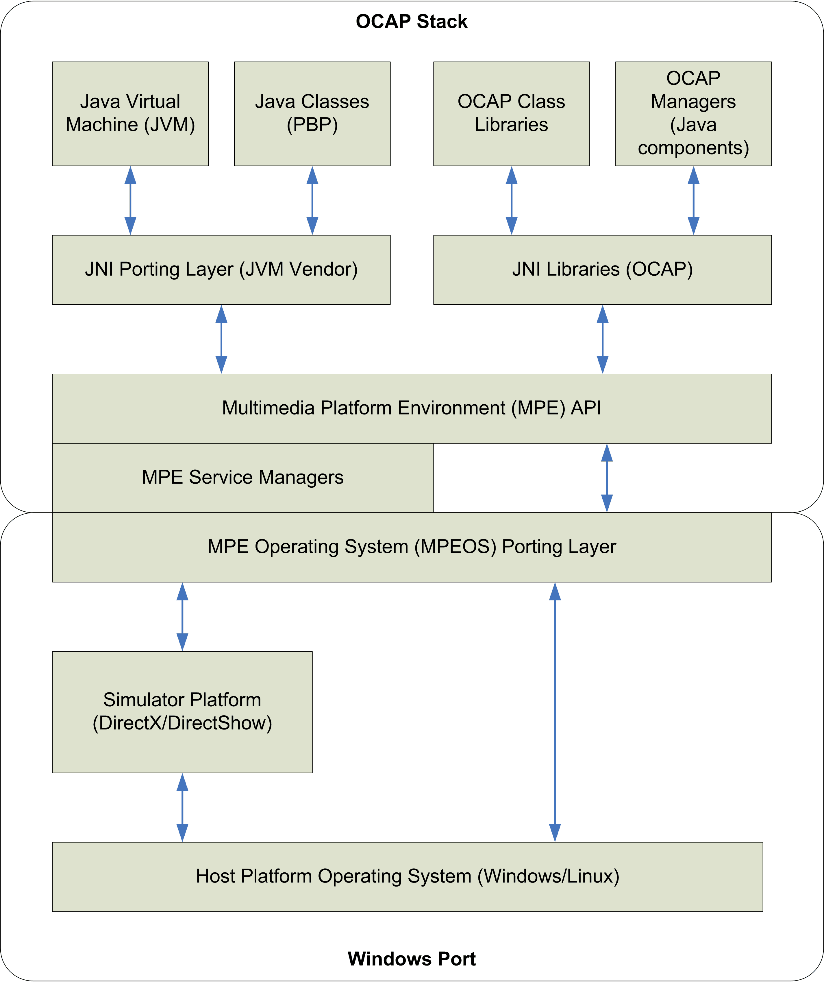
Figure 1-1: Porting Layer Architecture

JVM
The JVM is the Java Virtual Machine employed by the stack. The ODL Stack implementation is designed to allow the use of any JVM supporting the Java Native Interface (JNI). The JNI interface is used for creation and invocation of the JVM.
VISION Workbench v1.1 ER2 uses version XXX of the Esmertec JVM.

Java Classes
The Java classes consist of the set of Connected Device Configuration (CDC) – Personal Basis Profile (PBP) classes normally provided with the JVM.

OCAP Class Libraries
The OCAP class libraries are essentially the OCAP API classes defined within the specification.

OCAP Managers
The OCAP Managers are Java classes that are part of the implementation support for the OCAP APIs. These manager classes entail much of the control logic and state machine support defined or implied within OCAP.

JNI Libraries
The JNI libraries provide gateway access between the MPE layer and the OCAP Java managers. The various Java-based components of the OCAP system require bidirectional support fro the MPE. The degree of functionality within this layer can be as simple as mapping one API to another or as complex as providing algorithmic support such as data format translation, data encapsulation, and event registry and delivery.

JNI Porting Layer
The JNI porting layer is a thin abstraction allowing the JVM to access common operating system, middleware, and C runtime library operations.

MPE APIs
The MPE middleware is a collection of platform-independent APIs that provide multimedia-related services.

MPE Service Managers
The MPE service managers provide multimedia–related services. A number of these native MPE managers are very simple and provide only basic support for initialization of the MPE global function dispatch table for the APIs associated with that particular manager. Other managers contain much larger degrees of support for native subsystems. In particular, the file system manager, service information manager, and section filtering manager are examples of native subsystems that contain fairly large and complex implementations of platform independent functionality.

MPEOS Porting Layer
The MPEOS porting layer is where all direct references to the target platform operating system API are isolated. The basic operating system services are abstracted away from the bulk of the MPE code base and are bound at implementation time to the specific target system.

Simulator Platform
The simulator platform is the software that implements the functional behavior of the set top hardware. It provides behavior simulating the tuners and decoders that would normally be available in a real STB. It also interfaces with the VISION Workbench Headend Simulator, capturing full transport stream sections generated by that utility. User key events also flow through the simulator platform component.
The ODL Stack ported to Windows is built on the Windows Win32 and DirectX/DirectShow APIs.

Host Platform
The host platform is the specific target hardware and operating system. VISION Workbench targets the PC Intel platform running the Windows XP operating system.

Eclipse Platform
The Eclipse open-source tools platform provides the foundation and interface for VISION Workbench. Backed by the Eclipse Consortium and contributors such as IBM and Red Hat, the Eclipse Platform has become the IDE of choice for an increasing number of software developers. The strict plug-in architecture ensures that plug-ins written by other providers will work within VISION Workbench, giving the end-user the flexibility to customize the development environment to fit their needs.
One of the core components of the Eclipse platform is its Java IDE (or Java Developer Toolkit – JDT). The VISION Workbench plug-ins are designed to follow the JDT project workflow so that developers already familiar with the Eclipse IDE can use the same methodology for developing their OCAP applications. The VWB plug-ins have been integrated with the Eclipse platform and Java IDE to create a seamless, OCAP application development environment. These tools provide feature-rich editing, project management, compilation, testing and debugging support for developing OCAP applications.
VISION Workbench is based upon the Eclipse v3.2 release.

Client Simulator
The Client Simulator encapsulates a run-time environment that allows the application developer to test and debug OCAP applications on a PC running Windows XP without the hassles of testing on a digital receiver. The Client Simulator provides a user interface consisting of four modules
- TV Screen
- Virtual Remote Control
- Virtual Front Panel
- Trace Console
The TV Screen presents the OCAP application on a television-like device. The Client Simulator simulates a TV display by mapping the OCAP background, video and graphics planes to a Win32 Window. In addition to mapping the display to a Window, the Client Simulator enables the output to be displayed at full-screen, encompassing the entire screen of the PC’s computer monitor.
To test the application's interactivity, the Client Simulator includes a Virtual Remote Control that models the key codes for multiple remote control types. New remotes can be created and loaded into the simulator to reflect key mappings and functionality particular to a unique vender’s model.
The Virtual Front Panel is a user interface presenting the buttons and LED/LCD elements common on a set top box. Common key codes that are present on a STB are passed through to the OCAP middleware as if they came from a real OCAP device. As with the virtual remote control, new front panel configurations can be created and loaded into the simulator to model various vendors’ STB offerings.
The last user interface module in the Client Simulator is a console for viewing trace messages from the OCAP application and OCAP stack middleware implementation.

Headend Simulator
The Headend is responsible for the delivery of cable plant data, including video, audio, data, applications and signaling. Since the target PC platform contains no tuner/demodulator hardware, a simulation environment for those elements is provided in order to be able to deliver the cable plant data to the OCAP stack and its components.
The Headend Simulator is used to provide SI table information to the OCAP stack implementation. It constructs the PAT, PMT, SVCT, NTT and NIT tables and delivers them to the stack in real transport stream sections. The delivery mechanism is a resource manager that broadcasts the TS sections periodically over TCP/IP sockets.
The information to construct the SI tables is extracted from a channel map XML file. The application developer is responsible for configuring the XML file, mapping channels to frequency, qam, and program tuples that are used by the Headend Simulator to build the SI data.
The channel map XML file is also used to identify the location of MPEG-2 files containing the video and audio content associated with any given channel. The Headend Simulator tells the Client Simulator where these files are on the PC’s hard drive. The Client Simulator will then play back these files correlating to a tune request activated by the developer’s OCAP application.
Application signaling is currently handled through .properties files. XAIT signaling for unbound applications is configured via xait.properties files and AIT signaling for bound applications is configured via ait-xxxx.properties files. The xxxx identifies the service identifier for the bound application; for instance, ait-1234.properties binds the bound application with service 1234.

IDE Plug-ins
The enableTv Eclipse plug-ins are extensions to the Eclipse Java Developer Toolkit (JDT). The tools are used to create an OCAP Project that establishes a workspace environment for developing OCAP applications. The workspace includes default configuration files for signaling the application (e.g. xait.properties) as well as a default channel map for use with the Headend Simulator.
When the application developer is ready to test his application, he must create a JDT launch configuration. The OCAP launch configuration manager plug-in is used to execute OCAP Projects in both Run and Debug mode. In Run mode, the OCAP application is simply launched against the Client Simulator and allowed to run in free mode. In Debug mode, the Client Simulator (via the OCAP stack implementation) will attach to the Eclipse JDT debugger. Any breakpoints set in the Eclipse IDE source editor will be handled and processed as expected, allowing the application developer to symbolically debug his software.
VISION Workbench also provides online help through the Eclipse Help plug-in framework. For beginning OCAP developers, VWB provides getting started and support links through a Welcome screen that is prominently displayed the first time VWB is run.
  - Architecture Summary
This section presents a high-level view of the VISION Workbench architecture. Figure 2-1 shows a block diagram of the main components in this architecture. These components are
- The ODL Stack and MPEOS port to the Windows platform
- The Client Simulator
- The Headend Simulator
- The Eclipse v3.2 platform and enableTV plug-in extensions.

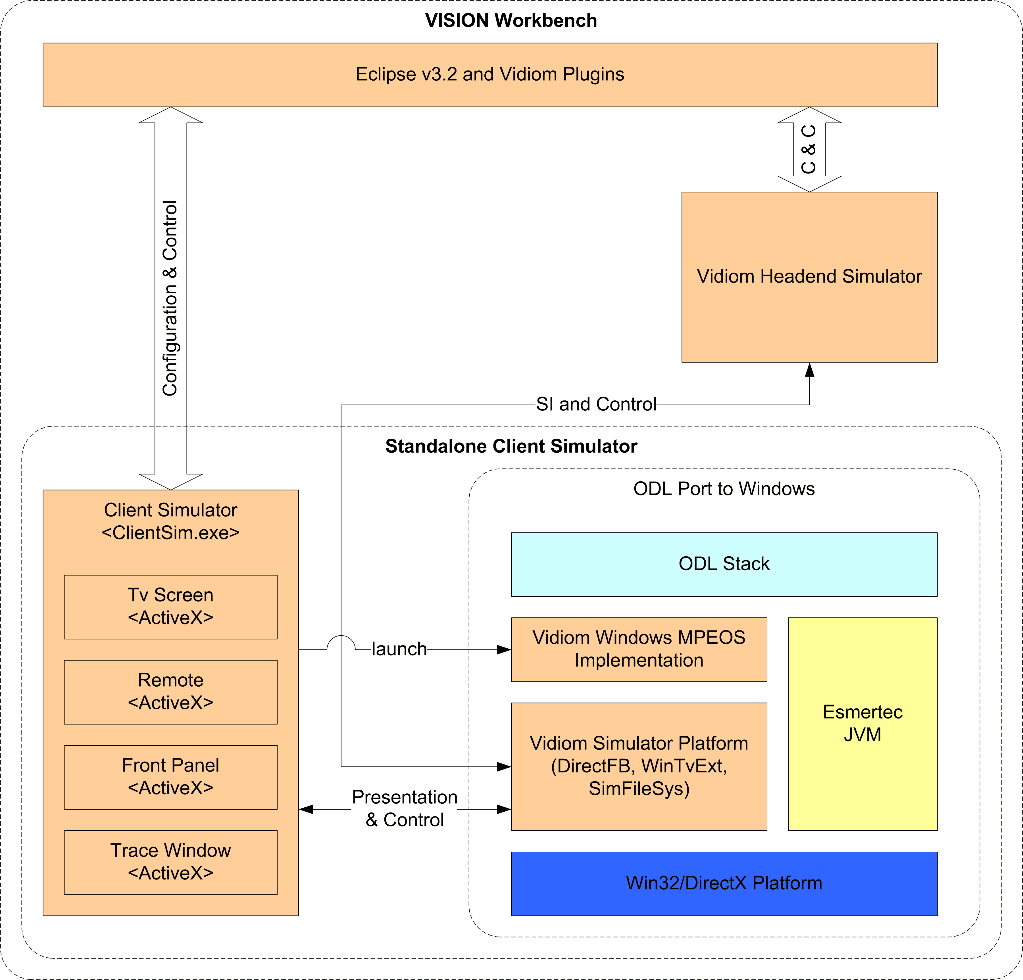
Figure 2-1: VISION Workbench Architecture

ODL Stack Port to Windows
XXX - Describe how the MPEOS Windows port is designed to work with the Client and Headend simulators. Identify the sub-components (DirectFB, WinTvExt and SimFileSys).

Client Simulator
XXX - Describe the ActiveX modules here. Also describe how the simulator is launched to start stack execution.

Headend Simulator
XXX – Describe how the simulator is configured and launched to deliver SI data to the OCAP stack.

Eclipse Platform
XXX – Describe the platform dependencies here.

enableTv Eclipse Plugins
enableTV has extended the Eclipse platform by developing tool plugins that specifically target the OCAP application developer. Table 2-1 lists these plugins.

VISION Workbench Plugin | Description
com.vidiom.vIDEA.jaxb | XML marshalling/unmarshalling support using JAXB
com.vidiom.vIDEA.log4j | Logging support using log4j
com.vidiom.vIDEA.propertyeditor | Editor support for Java properties file
com.vidiom.tool.license | License management
com.vidiom.tool.framework | Framework utilities
com.vidiom.tool.headend.networkmanager | The Headend Simulator
com.vidiom.tool.clientsim | The Client Simulator interface
com.vidiom.tool.ocap | OCAP Project environment utilities
com.vidiom.tool.ide.core | Core IDE environment
com.vidiom.vwb.ocap.core | The VISION Workbench Core feature
com.vidiom.tool.ocap.welcome | Welcome screen and out-of-box experience
com.vidiom.tool.ocap.help | Online help
com.vidiom.vwb.ocap.branding | Branding configuration
Table 2-1: VISION Workbench Eclipse Plugins

Figure 2-2 identifies how the plugins in table 2-1 are related to the rest of the Eclipse platform.

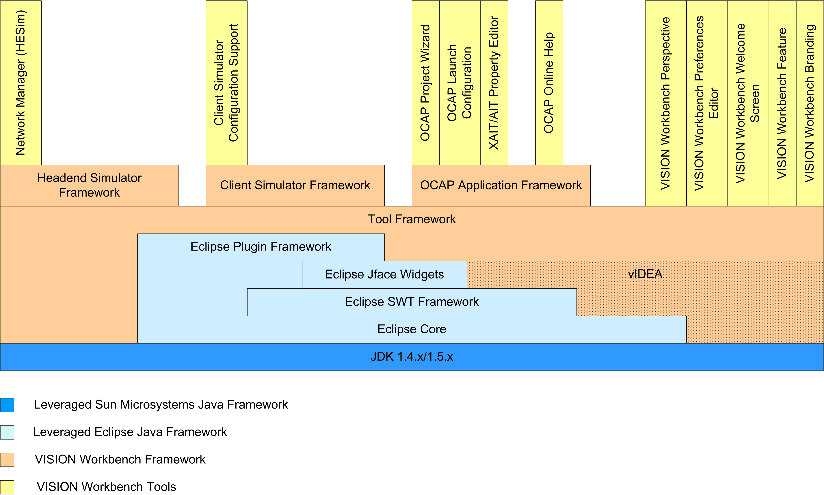
Figure 2-2: VISION Workbench Eclipse Plugin Architecture
  - Feature Set Summary
This section lists the features provided by VISION Workbench and a brief description of the provided functionality. The <tru2way> Workbench Priority column identifies whether the corresponding feature will be supported based on the following prioritization scheme
- R – the feature is required
- N – the feature would be nice it have
- X – the feature will not be supported

VWB Feature  Client Simulator | Description | <tru2way> Workbench Priority
Uses ODL, LLC. OCAP stack for application execution | The OCAP application is signaled and executed using the OCAP stack developed for the ODL, LLC. | R
All OCAP application types are supported | Both Unbound and Boud | R
Application can execute in normal, Run mode state | The OCAP application runs normally in a Release or Deployment configuration | R
Application can be symbolically debugged (Debug mode) | A Java debugger can be attached to the OCAP application using a Debug configuration | R
OCAP application is presented on a “TV Output” display | Presentation uses TV Screen ActiveX component | R
OCAP application can be presented on a full-screen Windows monitor | Presentation is mapped to entire screen real-estate of PC Monitor | R
The “TV Output” display can show the device’s safe-area. | This feature can be toggled on and off to outline the TV screen’s safe area | R
The “TV Output” display maps to required OCAP video and graphics resolutions | The simulator and stack can be configured for the following coherent configurations based on graphics resolutions:  - 640x480 4:3  - 960x540 4:3  - 640x480 16:9  - 960x540 16:9 | R
The “TV Output” display can be scaled into arbitrary sized devices | The simulator offers an autofit button for scaling the display to fit into a resized Window | R
The Video Plane can be hidden in the “TV Output” display | This feature can be toggled on and off to show/hide the video plane | R
The Graphics plane can be hidden in the “TV Output” display | This feature can be toggled on and off to show/hide the graphics plane | R
The “TV Output” display can be captured | A button is available for capturing the display screen | N
User input is captured through a virtual “Remote Control” | OCAP key input is captured through a remote control interface configured with the basic OCAP buttons. It is a ActiveX component. | R
The virtual “Remote Control” image can be changed | The current image is a Vidiom Remote Control device | R
The virtual “Remote Control” can be edited to respond to new key value mappings | These are made through the Remote Control Editor | R
The virtual “Remote Control” can be edited to map to virtual keyboard shortcut key values | These are made through the Remote Control Editor | R
Changes made to the virtual “Remote Control” are persistent across simulator sessions | The new or edited remote control key mappings are stored in a file that can be used to change the look-and-feel of the simulator’s virtual remote | R
The simulator can respond to IR codes from a real remote | This functionality is supported through the IRMan infra red receiver (not available anymore – switch to PCIR) | R
User input is captured through a virtual “Front Panel” | OCAP key input is captured through a front panel interface configured with the basic STB buttons. It is a ActiveX component. | R
The virtual “Front Panel” image can be changed | The current image is a Vidiom Set Top device | R
The virtual “Front Panel” can be edited to respond to new key value mappings | These are made through the Front Panel Editor | R
The virtual “Front Panel” can be edited to map to virtual keyboard shortcut key values | These are made through the Front Panel Editor | R
The virtual “Front Panel” LEDs can be configured | These are made through the Front Panel Editor. Parameters such as color, blink rate and brightness can be specified | R
Changes made to the virtual “Remote Control” are persistent across simulator sessions | The new or edited front panel configuration is stored in a file that can be used to change the look-and-feel of the simulator’s set top box | R
Messages output from the OCAP stack implementation are displayed in a console Window | The Trace Window is an ActiveX component. Stack messages are captured from a socket and redirected to the window. | R
Messages output from the OCAP application are displayed in a console Window | The Trace Window is used for application output. Messages sent to System.out and System.err are captured and redirected to the window | R
The console window can be cleared of all messages |  | R
Messages in the console window can be refreshed |  | R
Messages in the console window can be selected for cut-and-paste operations |  | R
Output to the console window can be paused and resumed |  | R
Output to the console window can be saved to an external file |  | R
Text strings can be searched for in the console window |  | N
Output to the console window can be filtered based on category and level | Current categories include Simulator, OCAP, WinTvExt, Headend, StdOut and StdErr. Levels are controlled through the mpeenv.ini file | R
The simulator can run in a standalone configuration using command-line execution | A Windows application including the TV Screen, Remote Control, Front Panel and Trace ActiveX components can run independent of the Eclipse IDE | R
Table 2-2: Client Simulator Features

VWB Feature  Headend Simulator | Description | <tru2way> Workbench Priority
The simulator delivers SI over an Inband channels | PAT and PMT tables are delivered over sockets simulating InBand. SVCT, NIT and NTT tables are also delivered over these sockets. | R
The simulator delivers SI over an Out of Band channel | This feature is not currently being employed | R
The simulator communicates which MPEG-2 files to play back in response to tune requests | A control channel is used to communicate the file path. The files are specified through the ChannelMap.xml | R
The simulator can extract SI data from MPEG-2 Transport Stream files | Audio/Video playback is not supported. The TS file is specified through the ChannelMap.xml | R
Tuning support by source ID | Specified through ChannelMap.xml | R
Tuning support by frequency, QAM, and program | Specified through ChannelMap.xml | R
Supports XAIT signaling | This is done through .properties files consumed directly by the OCAP stack implementation | R
Supports AIT signaling | This is done through .properties files consumed directly by the OCAP stack implementation | R
Supports Object Carousel | If embedded in the MPEG-2 Transport Stream file | R
Table 2-3: Headend Simulator Features

VWB Feature  IDE and Application Development Workflow | Description | <tru2way> Workbench Priority
Based on Eclipse JDT technology platform | Currently using v3.2 of Eclipse. OCAP source development is offered all of the features provided by the Eclipse Java Development Toolkit | R
Create project workspace for application development | The OCAP Project Wizard is used to do this | R
Provides application templates | Two templates are currently provided, Simple and HelloWorld | R
Provides default Headend Simulator configuration | Default ChannelMap.xml is created by the OCAP Project Wizard. Default signaling files (XAIT and AIT .properties files) are also created by the OCAP Project Wizard. | R
Provides default Client Simulator configuration | Application properties are associated with the OCAP Project. | R
Headend Simulator configuration can be customized by application developer | A .properties file editor is provided for editing the signaling parameters. The ChannelMap.xml file can be edited using a text file editor. | R
Client Simulator configuration can be customized by application developer | Properties on the OCAP Project can be edited though an Eclipse Project Properties editor. | R
Provides default OCAP Stack configuration | Default mpeenv.ini file is distributed with VWB | R
OCAP Stack configuration can be customized by application developer | Changes made to the mpeenv.ini file via a text editor | R
OCAP application may be executed in Run mode | A launch configuration manager is provided for creating and running in this mode. The Client and Headend simulators are automatically started, launching the OCAP xlets associated with the OCAP Project. | R
OCAP application may be executed in Debug mode | A launch configuration manager is provided for creating and running in this mode. . The Client and Headend simulators are automatically started, launching the OCAP xlets associated with the OCAP Project. | R
Welcome screen for beginning users | Support links and general OCAP application development getting started help is presented here | N
Help documentation | The user programming guide for VWB | X
OCAP tools perspective | A workflow view for application development. Used to present a common interface for OCAP-specific work items. | R
Global properties configuration editors | Configuration parameters that are global across multiple OCAP Projects are outlined and presented via the Window->Preferences menu | R
Table 2-4: IDE Features
Note that these tables do not identify the coverage or completeness of the OCAP stack implementation. That information is made available in the document XXX.

<tru2way> Workbench
3 IR Manager Command Details
This section describes the <tru2way> Workbench IDE being developed by CableLabs.
  - Overview
The goal of <tru2way> Workbench is to assist the end-user in creating and testing their OCAP software solution. The <tru2way> Workbench will provide an environment to edit, compile, debug and test an OCAP application in an environment that approximates a complete end-to-end cable system. A major distinction between the <tru2way> Workbench and enableTV’s VISION Workbench will be its capabilities to emulate the STB hardware. <tru2way> Workbench will be able to play back MPEG-2 Transport Streams that have been previously captured to a local hard-drive’s file system. The <tru2way> Workbench will also be able to play back live transport streams from a QAM Receiver (i.e. PC Digital TV PCI hardware).
Like VISION Workbench, the toolset plans to do this through development and integration of Eclipse editors, compilers, GUI builders, client API emulators, headend simulators and other utility tools. The result will be an environment that can be run on a PC (or network of PCs) and provide a complete development and testing environment for an application builder.

Product Components
<tru2way> Workbench is comprised of approximately five components. These components are
- The ODL Stack and MPEOS port to the Windows platform
- The Reference Implementation Emulator
- The Headend for RI Emulator
- The Eclipse v3.4 platform
- The tru2way plug-in extensions

ODL Stack and Windows Implementation
The <tru2way> Workbench RI Emulator will be based on the OCAP middleware stack developed for the OCAP Development, LLC. To run on the Windows platform, the ODL Stack will be ported and the missing set top hardware (e.g. tuners and MPEG Transport Stream decoders) will be emulated on top of the Windows Win32 and GStreamer APIs. The graphics capabilities will incorporate OpenGL, version 2.0.
Figure 1-1 illustrates the porting layer architecture employed by the VISION Workbench Client Simulator. This architecture will be leveraged by the RI Emulator. Note that the Simulator Platform components will be replaced by the RI PC Platform components based on GStreamer, UPnP and other technology that are not part of the enableTV solution.
The RI ODL Stack will use the Sun Microsysems’ J2ME Connected Device Configuration (CDC) as specified by the OCAP 1.0.1 Specification [OCAP]. The OCAP Specification is compliant with the Personal Basis Profile v1.1 [PBP].

RI Emulator
The RI Emulator is comprised of the ODL middleware stack ported to the PC Platform. In addition to the Windows port, the RI Emulator will provide a user interface for presenting the video and graphics employed by an OCAP application running on top of the OCAP Stack. User input will be captured through a virtual remote and forwarded to the middleware implementation for processing. The RI Emulator will also display messages produced by the stack and OCAP application in a console window.

HE4RI Emulator
The Headend for RI is a partial implementation of the Digital Receiver Interface 2.0 (DRI) specification. It is used to deliver cable plant data normally provided by a headend. This data includes video, audio, data, applications and signaling (i.e. AIT, XAIT, …).

Eclipse v3.4 Platform
The <tru2way> Workbench will be based upon the Eclipse v3.4.1 release, also referred to as Ganymede.
The “Ganymede/For Users” Eclipse project web page identifies what is new and noteworthy in this release. The web page URL is “http://wiki.eclipse.org/Ganymede_Simultaneous_Release/For_Users”.

<tru2way> Plug-ins
The <tru2way> Workbench will extend the Eclipse Platform to provide the functionality for developing and testing an OCAP application. The Eclipse Java Development Toolkit (JDT) will be leveraged to provide an application workspace, called an OCAP Project, where the application source can be edited, compiled and debugged in an integrated interactive development environment.
The OCAP Project is where configuration and control parameters are managed for a collection of OCAP applications (as defined by the application developer). Initially, many configuration elements will be specified here for controlling the RI Emulator and HE4RI. Eventually, these configuration parameters will be managed via a workflow that is more “Network Centric”.
Following the Eclipse Platform paradigm, the OCAP application is executed via an OCAP Launch Configuration. A Launch Configuration defines the information for running programs. With launch configurations, the application developer specifies input parameters, JVM arguments, environment variables, source locations for the code, and settings for the runtime classpath and JRE. The <tru2way> Workbench will provide launch configurations for both Run and Debug modes of execution.
  - Feature Set
This section identifies the feature set that is being planned for the <tru2way> Workbench. The features are organized in a phased
  - Architecture
This section presents a high-level view of the <tru2way> Workbench architecture. Figure 3-1 shows a block diagram of the main components in this architecture. These components are
- The ODL Stack and MPEOS port to the Windows platform
- The Reference Implementation Emulator
- The Headend for RI Emulator
- The Eclipse v3.4 platform and <tru2way> plug-in extensions.
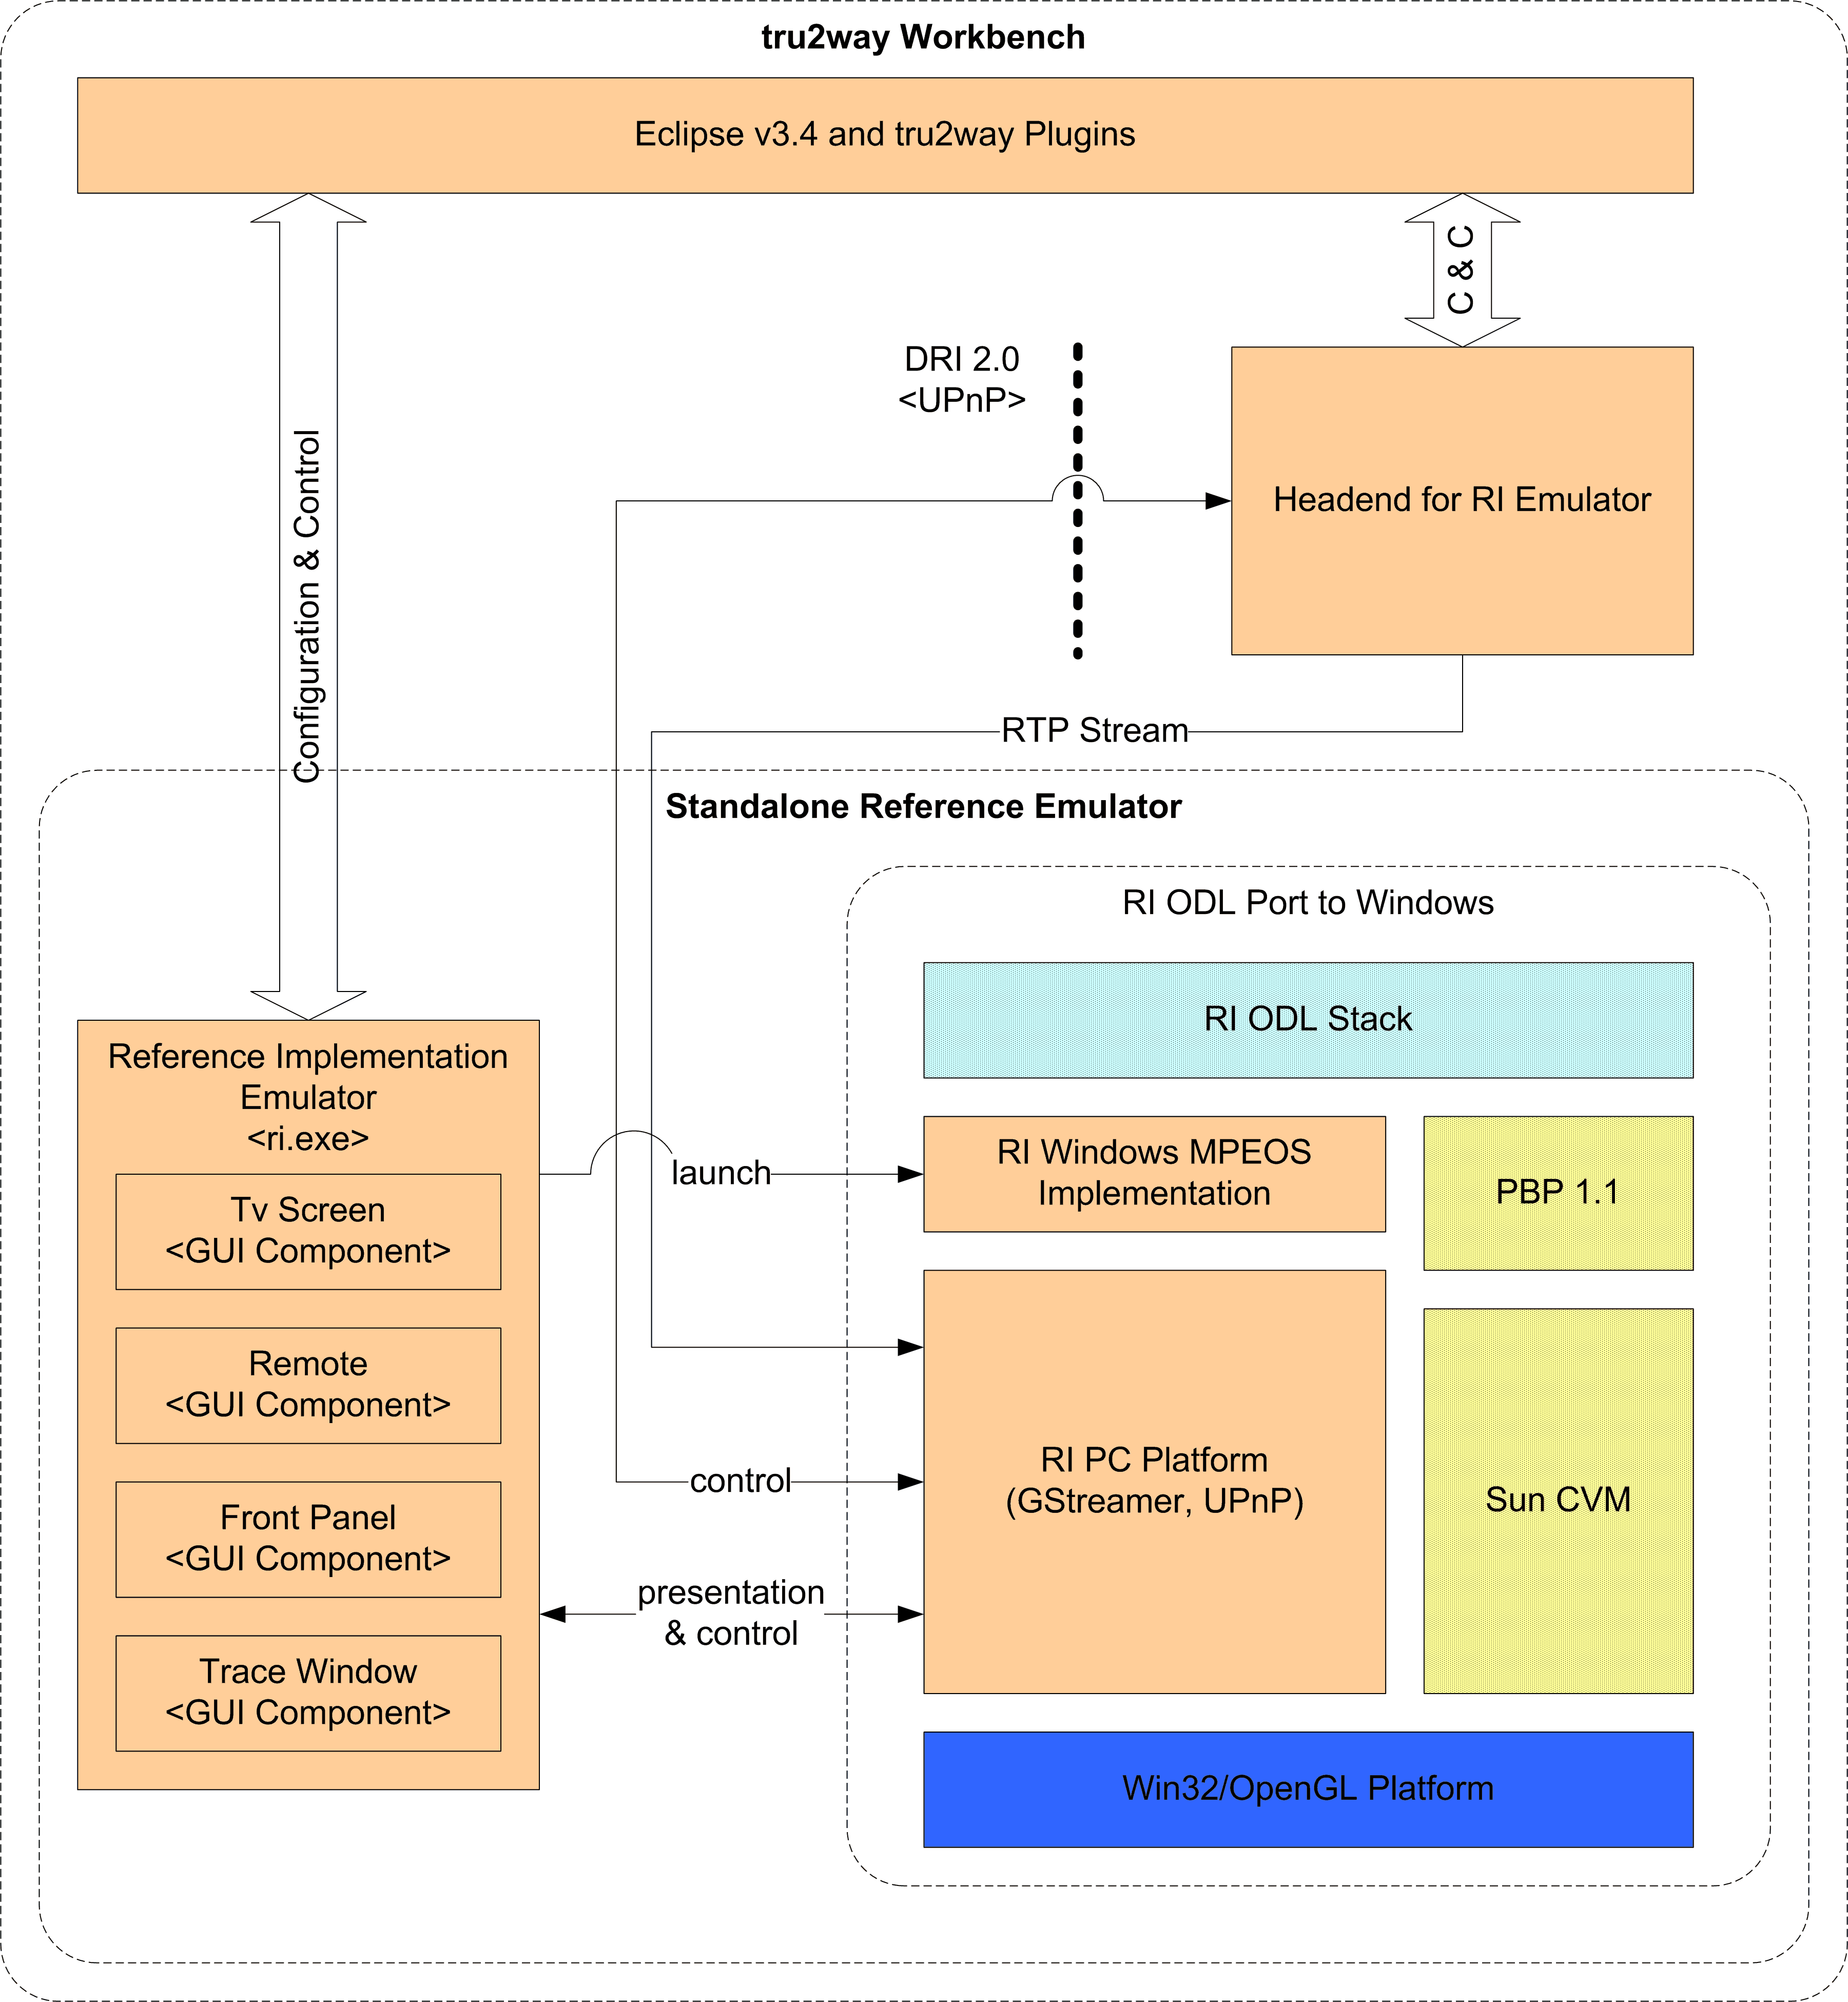
Figure 3-1: <tru2way> Workbench Architecture

ODL Stack and Windows Implementation
XXX

Reference Implementation Emulator
XXX

Headend For Reference Implementation (HE4RI)
The Reference Implementation Project aims to provide an open-source, PC-based platform for developing and testing OCAP applications. One of the initial primary goals of the RI is interoperability with the existing ATE software that runs the CTP test suites. As such, the underlying software “glue” layer between the existing ODL stack code and a target PC platform needs to incorporate an MPEG engine capable of acquiring, de-multiplexing, filtering, decoding and presenting MPEG-2 transport streams.
One of the pieces of such a PC-based MPEG engine is the delivery of cable plant data, including video, audio, data, applications and signaling. Since the target PC platform contains no tuner/demodulator hardware, a simulation environment for those elements needs to be provided in order to be able to deliver the cable plant data to the OCAP stack and its components.
The DRI 2.0 interface offers one such abstraction. The HE4RI is a simulation of the DRI 2.0 interface, delivering MPEG-2 Transport Streams using the Real-time Transport Protocol (RTP).

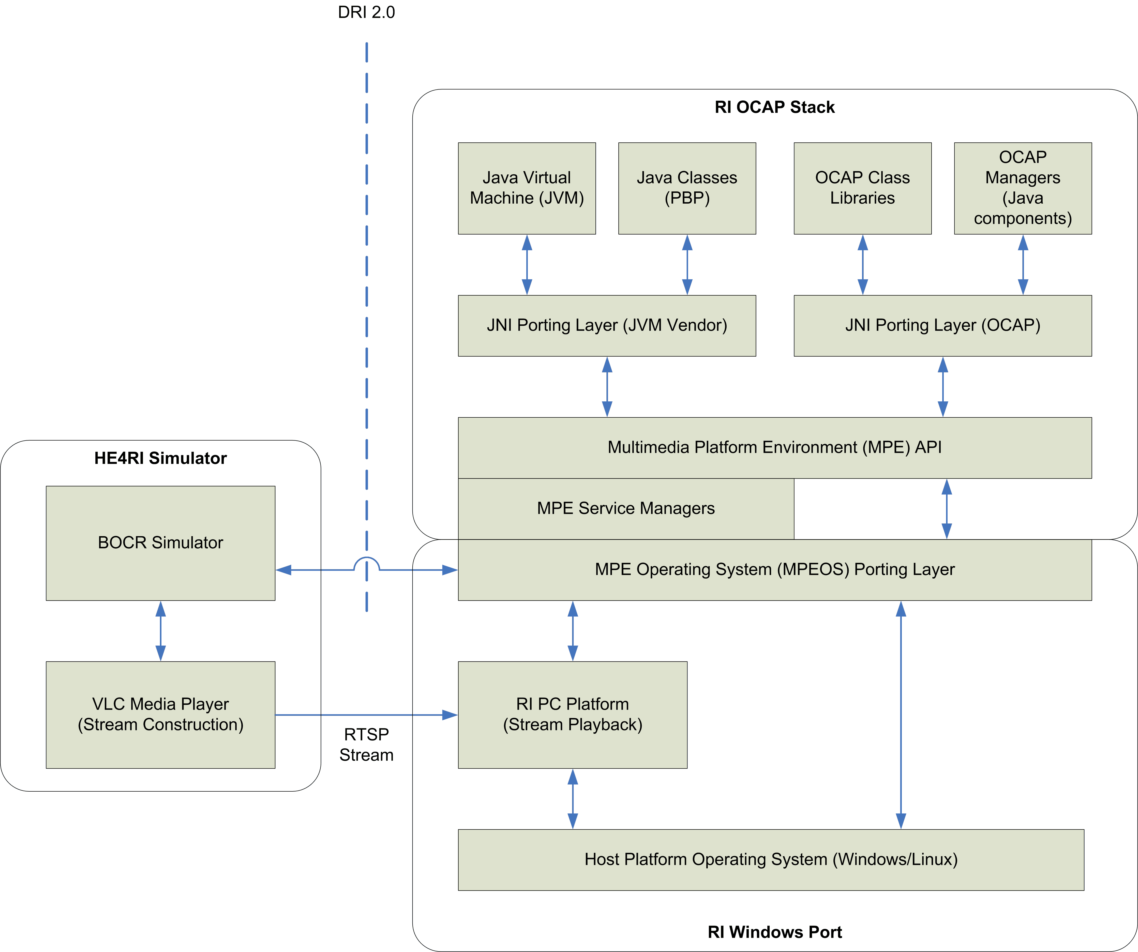
Figure 3-2: Reference Implementation Emulator Context

Figure 3-2 identifies the relationship between the RI OCAP Stack, the MPEOS porting interface to the RI PC Platform and the Headend for RI (HE4RI) simulator.
XXX – Don Burt and Steve Maynard should provide more context here

MPEOS-comm
Following is an outline of a minimal subset of the required DR I2.0 components (called collectively the “MPEOS-comm”) that will need to be implemented by the RI PC Platform in order to be able to run CTP test suites.
In order to present a coherent and minimal set of functional interfaces to the RI, the MPEOS-comm needs to incorporate the following modules:
- A UPnP stack.
- A subset of DRI 2.0 Core Services.
- A subset of OCAP Secure Service.
- A Streaming Interface.
- A TCP Exchange Pipe (TEP) service.
UPnP stack
To ease the code integration effort, a C or C++ based UPnP stack implementation is introduced. The RI PC Platform will use the CyberLink for C (http://www.cybergarage.org/net/upnp/c/index.html) open source from CyberGarage.
DRI 2.0 Core Services
The following subset is required:
[DRI2.0] 7.2 | Eventing Service
[DRI2.0] 7.2.1 | GenaEvent: PendingEvent
[DRI2.0] 7.2.2 | GetEvent()
[DRI2.0] 7.2.3 | CompleteEvent()
[DRI2.0] 7.3 | Tuner
[DRI2.0] 7.3.1 | SetTuner()
[DRI2.0] 7.3.2 | GetTunerState()
[DRI2.0] 7.3.3 | GetSignalDiagnostics()
[DRI2.0] 7.3.5 | GenaEvent: SignalLock
[DRI2.0] 7.4 | General Purpose Name Value Service (GPNVS)
DRI2.0] 7.4.1 | SetValue()
[DRI2.0] 7.4.2 | GetValue()
[DRI2.0] 7.5 | DRM
Not Required
[DRI2.0] 7.6 | CAS
Not Required
[DRI2.0] 7.7 | MUX
Not Required
[DRI2.0] 7.8 | SCANNING
Not Required
[DRI2.0] 7.9 | DEBUG (optional)
Not Required
[DRI2.0] 7.10 | Aux Service
Not Required
[DRI2.0] 7.11 | Encoder Service
Not Required
[DRI2.0] 7.12 | FDC
[DRI2.0] 7.12.13 | RequestTables()
[DRI2.0] 7.12.12 | GenaEvent: FdcTableSection

OCAP Secure Service
The following subset is required:
[DRI2.0] 8.2 | OCAP Priviledged API (OPA) Service
[DRI2.0] 8.2.1 | GetOpaRegistrationStatus()
[DRI2.0] 8.2.2 | RequestOpaRegistration()
[DRI2.0] 8.2.5 | GetTepCapabilities()
[DRI2.0] 8.2.6 | GetTepStatus()
[DRI2.0] 8.2.6 | RequestCfd()
[DRI2.0] 8.2.7 | GetCfdStatus()

For 8.2.5, 8.2.6, 8.2.7 and 8.2.8, the original requirement of “Valid when not OPA-paired” is removed.
Streaming Interface
For MPEG-2 transport stream delivery, the RTSP protocol will be used to pass the audio/video data. Since no transport DRM is defined, the following needs to be clarified:
- How to define a streaming session.
- How to communicate the identifier of the streaming session to the RI.

TCP Exchange Pipe (TEP)
At this point, no TEP support is required. The RI will use its host PC TCP/IP stack for external IP communications.

User Configuration Control
This section identifies the data required for the current HE4RI emulator, and describes the implications for user configuration and/or runtime tools. The user configuration suggestions are included for Phase 1 and Phase 2 or later versions.
The HE4RI configuration data is essentially in five classes:
- GPNVS name-value pairs, which emulate STB and CableCard data
- FDC configuration data, defines data received from DSG or OOB sources
- Tuner data. Defines actual sources and the emulated SI data that references them
- XAITs, OOB signaling data
- FAT channel data, the files that are played as actual sources
GPNVS data
The GPNVS data is currently loaded from an XML file that defines the names and values, along with flags that control details of the use of that pair. Names can be read-only, read-write, or write-only. They can also be global (defined across all tuners of the device) or local (specific to a single tuner). They can be transient (reloaded each time) or persistent (updated in the file at exit). They may be evented, delivering a client asynchronous message any time they change. Finally, they can represent a method call instead of a data assignment, a feature intended primarily for MMI and not used in the current emulation.
There is a predefined set of GPNVS values that must be present. Proprietary additions can be added to the configuration if desired, and can even be added at run time.
All the configuration should be exposed in the HE4RI configuration tool. It would be desirable for the HE4RI run time interface to allow viewing and altering GPNVS values. Phase 1 should probably expose at least those names that are evented, but might do all.
FDC Data
FDC Configuration data is currently loaded from an XML file. Some details will probably be updated to reflect the recently issued DRI2 Draft 03 document. The configuration identifies binary section files that are to be played into the HE4RI emulation. These files are organized into ‘carousels’ for management purposes, as a carousel can be stopped or started as a unit. Each file is identified as a component of the carousel. When the carousel is stopped, components within it can be enabled, disabled, or even added and deleted. The component is the finest level of control available, when enabled all its sections are played. Carousels are in two forms, cached or continuous. A cached carousel, representing OOB SI data, is delivered through the FDC UPnP service, with the cache holding the most recent set of unique section data and supplying it on request. A continuous carousel, representing an OOB DSM-CC carousel, is delivered through the CFD socket mechanism and plays continuously.
Phase 1 should present the configuration data. It would be desirable for the Phase 1 HE4RI run time interface to be able to control all carousels and their components. For example, a EAS message could be triggered by selecting a particular pre-recorded EAS section file and enabling its carousel. Phase 1 will probably not include OOB carousels, as there is very little deployed use of that facility and the H34RI has not yet implemented them.
Tuner data
The Tuner configuration is currently in a coma-delimited text file, with the first field identifying a record type. This was adopted to speed prototyping of the implementation, and will be moved to an XML form at some point. The configuration file contains five kinds of data. These are:
a) The number of UPnP tuners. This is currently implied from the source definitions. All tuners must have the same set of sources, so for n tuners there must be exactly zero or n sources of each source type.
b) Input source definitions. A source is currently either a streamer for transport files (currently via VLC), or a stream forwarded from live QAMs (current Silicondust HD HomeRun). Each definition supplies the parameters necessary to create an instance a distinct source of that type at HE4RI run time.
c) Actual transport stream definitions. Each actual stream definition supplies a source type and the parameters necessary to acquire that stream from the source. E.g., the file data for a file source or tuning data for a live source.
d) Virtual transport stream definitions. Each virtual stream definition describes the RF and SCTE-65 data of a nominal transport stream that can be accessed by the RI. It also references that stream to an actual definition. The RF data includes the nominal signal quality, etc, and the SCTE-65 data includes the frequency, modulation mode, source-ID, transport ID, and so on.
e) Program (or Service) definitions. Program data is defined by source id, virtual channel, program number, and call letters, and assigned to a virtual transport stream. This must reflect the actual program data present in the corresponding actual transport stream.
Note that if the virtual stream definitions are not matched to the actual SCTE-65 data supplied to the FDC, or tuning failures will occur when the RI attempts to tune based on the SCTE-65 data. In the current implementation this correspondence is enforced by constructing the FDC virtual transport stream and program data from the actual SCTE-65 channel data.
All this configuration should be exposed in the HE4RI configuration tool. The need for correspondence between the actual FAT streams, the SCTE-65 section files, and the Tuner configuration data must also be addressed. For Phase 1 this can be done by releasing the RI with all these files having been manually correlated, along with instructions for manually changing the configuration. In Phase 2, stream analysis tools could provide the information from recorded files, and the HD Homerun can be used to get the definition of a tuned channel. With this data loaded into the Tuner configuration, SCTE-65 table generators could construct the corresponding channel map section files.
XAIT data
The HR4RI currently sees XAITs only as binary section files. It has an optional default XIAT section file that will be considered part of the FDC section data on startup. After startup, a XAIT can be supplied using the Cablelabs OOB specification (OC-SP-OOB-I01-051118, as used on the DNCS and DAC) and that new XAIT will replace the current XAIT.
The HE4RI configuration tool should be able to generate an XAIT matching the user configuration. In general, the user would define a set of applications and use settable XAIT attributes, with the IDE providing the transport and class information. This would be used to generate an XAIT. All the above might use the existing properties file mechanism for Phase 1. In any event, the XAIT would be used to build a transfer kit, and post it to the HE4RI OOB port. Presumably the transport would be an interactive channel, fed from an http server pointing to the compiled classes. The simplest option is probably to place that server on the HE4RI and populated it with the class data. Subsequent phases could both provide better application environment definition tools and also use the CoDF interface (OC-SP-CoDF-I01-080114) to post it to any compliant stream generator.
FAT channel data
The current implementation supports two forms of data source, files and live QAMs. The IDE can be distributed with pre-defined transport files and correlated FDC SI data and tuner configurations. If the channel maps are built dynamically, users could add or substitute their own files by changing the actual transport definition and program definitions in the tuner configuration.
Users who selected to use live QAMs could attach an HDHomeRun device and use it to access any unencrypted cable channel. Again, assuming dynamic channel maps, the actual transport definition and program definitions would have to be modified in the tuner configuration.

Eclipse Platform and <tru2way> Workbench Plugins
XXX

<tru2way> Workbench Wish List
  - Layout/UI Builder
One of the missing pieces of this tool suite is the ability for the application builder to easily create a user-interface for their iTV application. A Graphics Layout editor would add the capability of a drag-and-drop editor for visually laying out the graphics elements of an application. Using a “scene” metaphor, elements (buttons, text, images) may be placed on the display and then customized as per their foreground/background colors, fonts, sizes, strings, and behavior. Limited branching capabilities can also be included which tie one “scene” to the next.
This layout can subsequently be used for generating code (specific to the selected target environment) or for simulation to verify the response of the graphics elements to user input. An application developer could then take the generated code and customize it for more complicated functionality.

Audio/Video Elements
An important component of the UI Builder is the ability to place Video windows on the display as well as to synchronize audio clips with the graphics elements. This would be a required feature of the Layout Editor.

Support for Application Templates
An optional plug-in component for the UI Builder could include application templates for standard types of applications (such as Video on Demand or Local City Guides) that would supply all of the custom code in a ready to use format. Once the layout is customized, a fully deployable application is ready for distribution.

Support for Code Generation
In conjunction with the UI Builder, a code generator would parse the UI layout and generate the appropriate source code, based on the selected target configuration.

Target Configuration Constraints
An important feature of the UI Builder would be the ability to model the constraints of a specific target set top box. For example, constraints may be applied which limit the number of colors available, the image formats available, or the ability to scale / reposition the video window. With the proliferation of set tops available, it is often difficult for a designer to keep all of those constraints in mind.

<tru2way> Workbench UML Diagrams

Use Case Diagram 1: Application Development Workflow
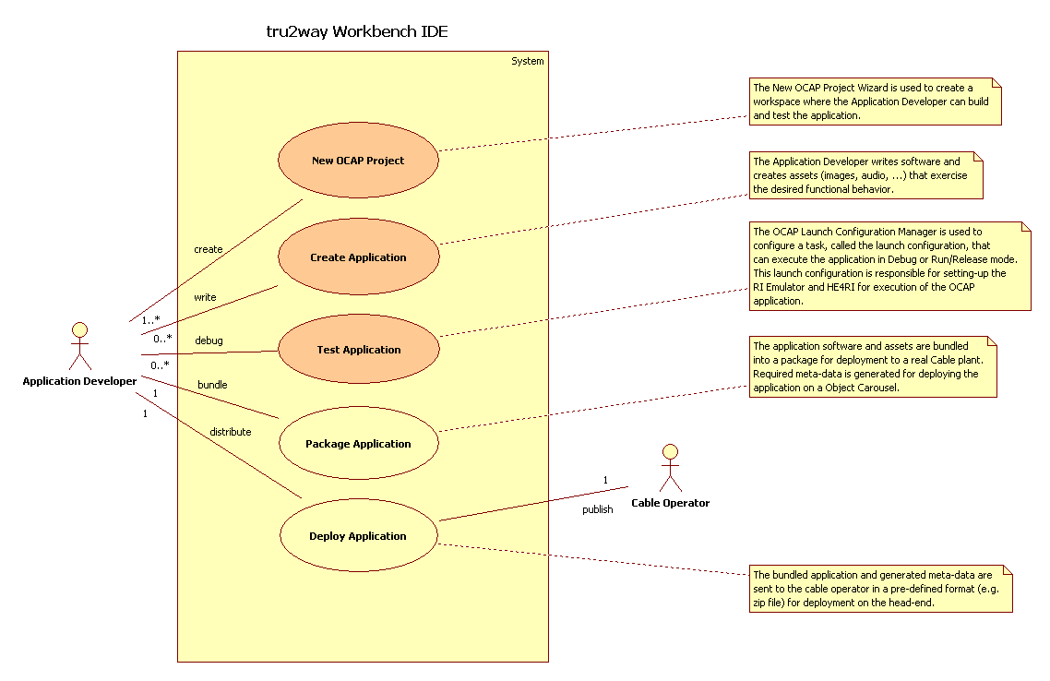

State Diagram 1: Create a New OCAP Project
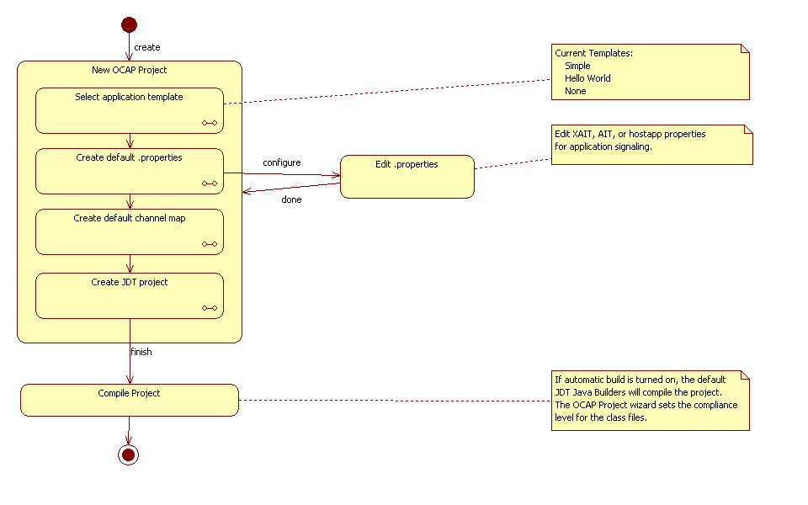

State Diagram 2: Launch an OCAP Project Application
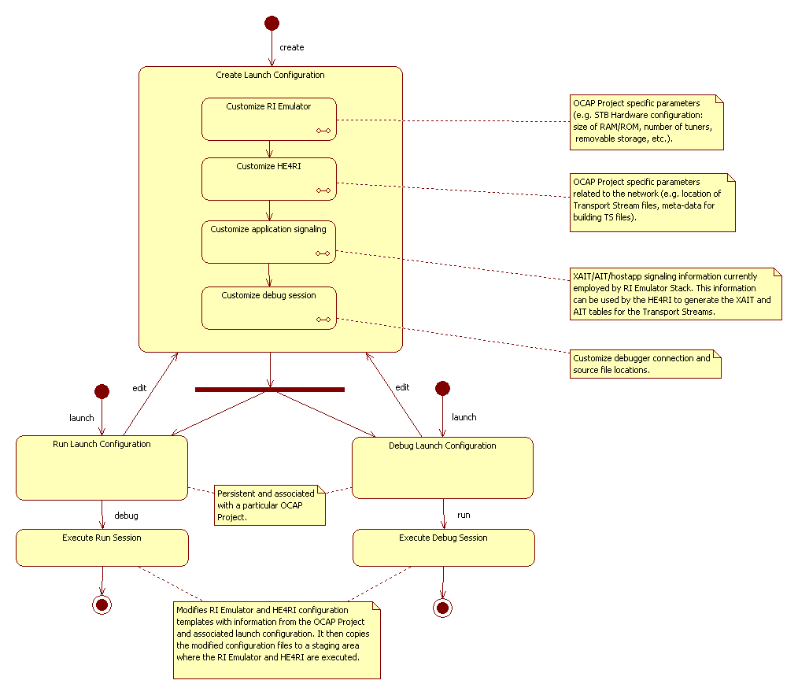

A PC platform refers to an Intel architecture running either Microsoft Windows XP, Microsoft Vista or Linux.
See http://www.eclipse.org
See http://www.netbeans.com

